1. We will see multiple-inheritance in java.
2. So we will create 3 interfaces and one implementation class.
3. Code:
   1. 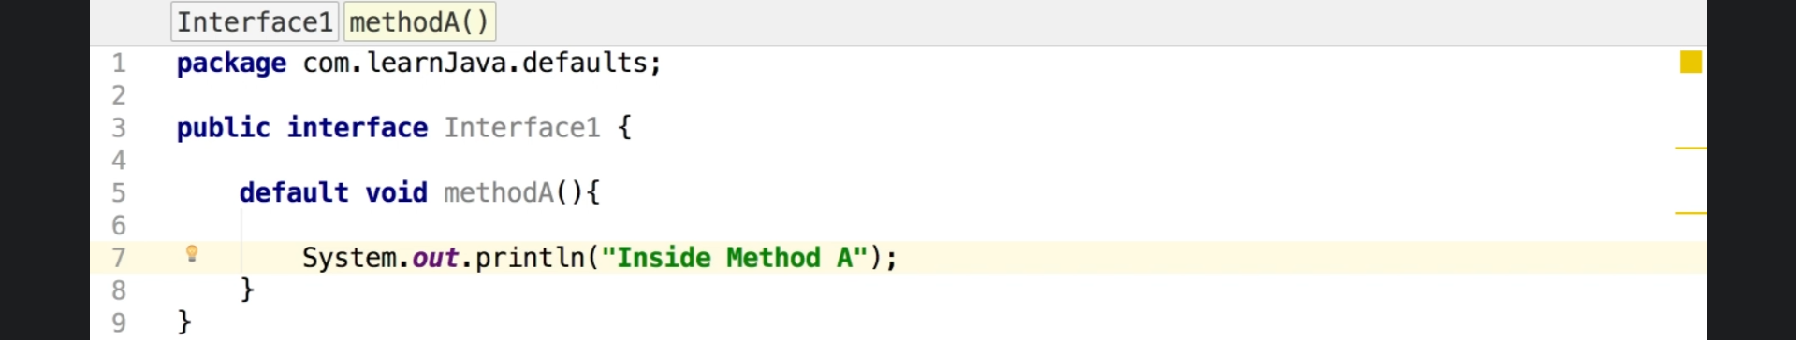
   2. 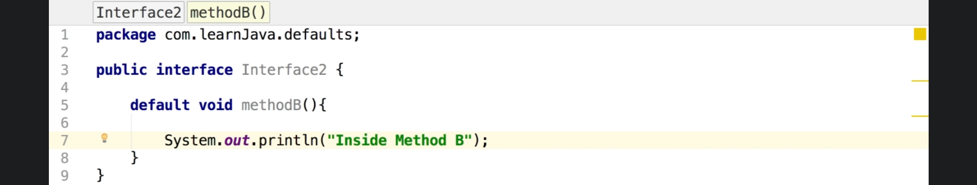
   3. 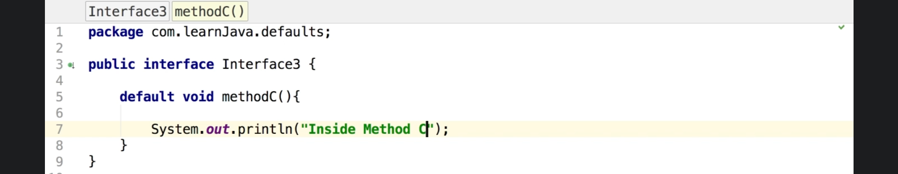
   4. Till now we created just 3 interfaces each having one fully implemented method.
   5. 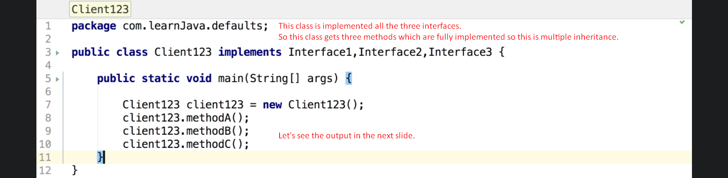
   6. 
   7. 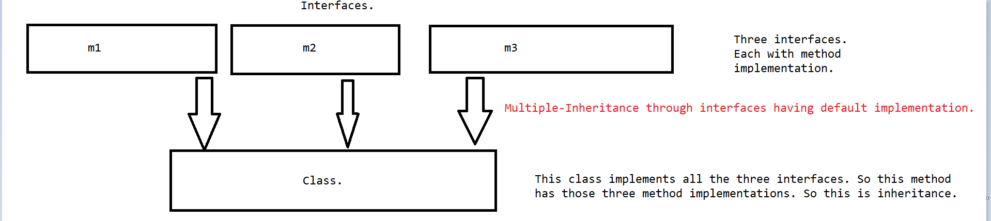
4. Let’s add some complexity into it.
   1. 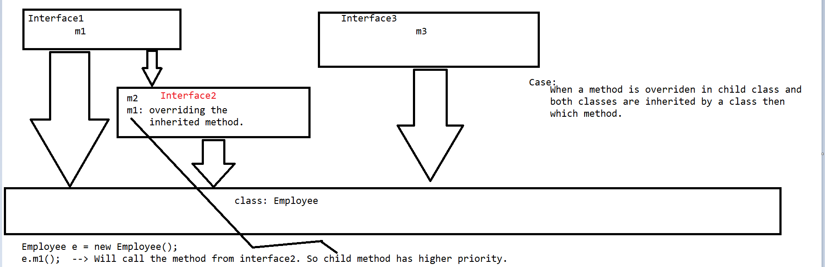
   2. 